Jenkins Integration

# Steps to Open Jenkins

If Jenkins is not installed in your system install it from website Jenkins.io and download a jenkin.war file.

1. Open the location of the war file.

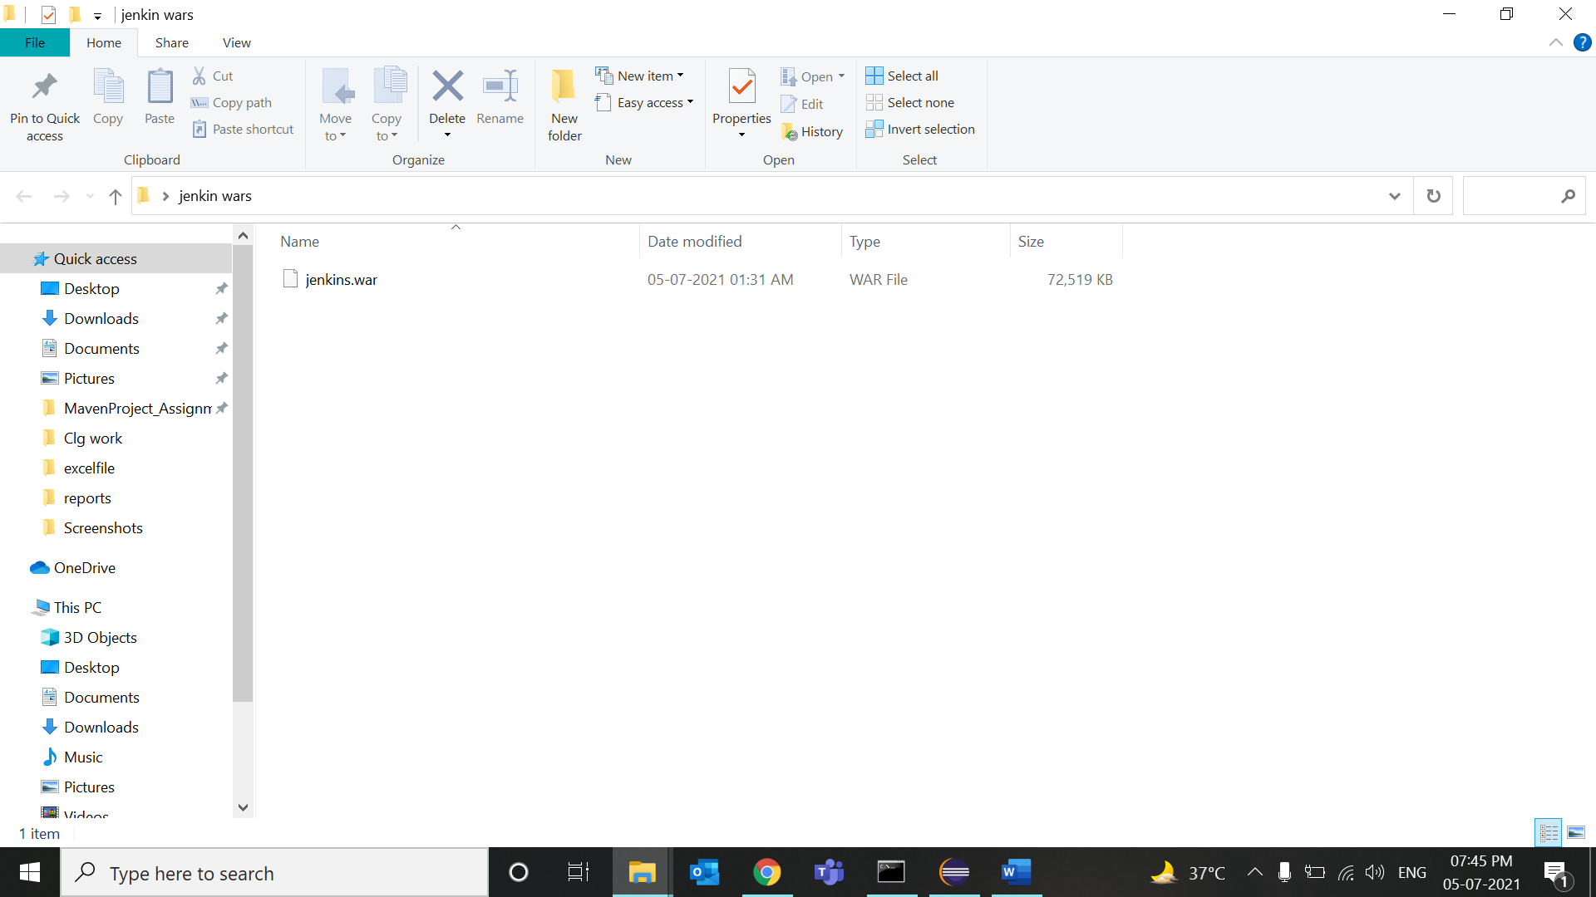

1. And Open cmd in that location.

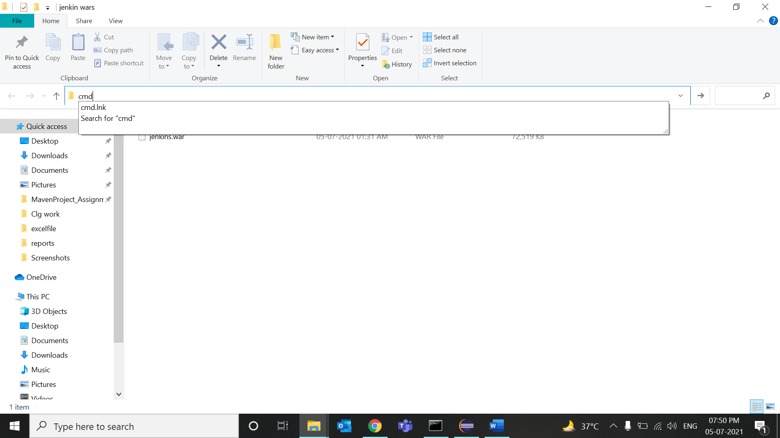

1. Write java -jar Jenkins.war –httpPort=8082 (if your port is different, change the port number)

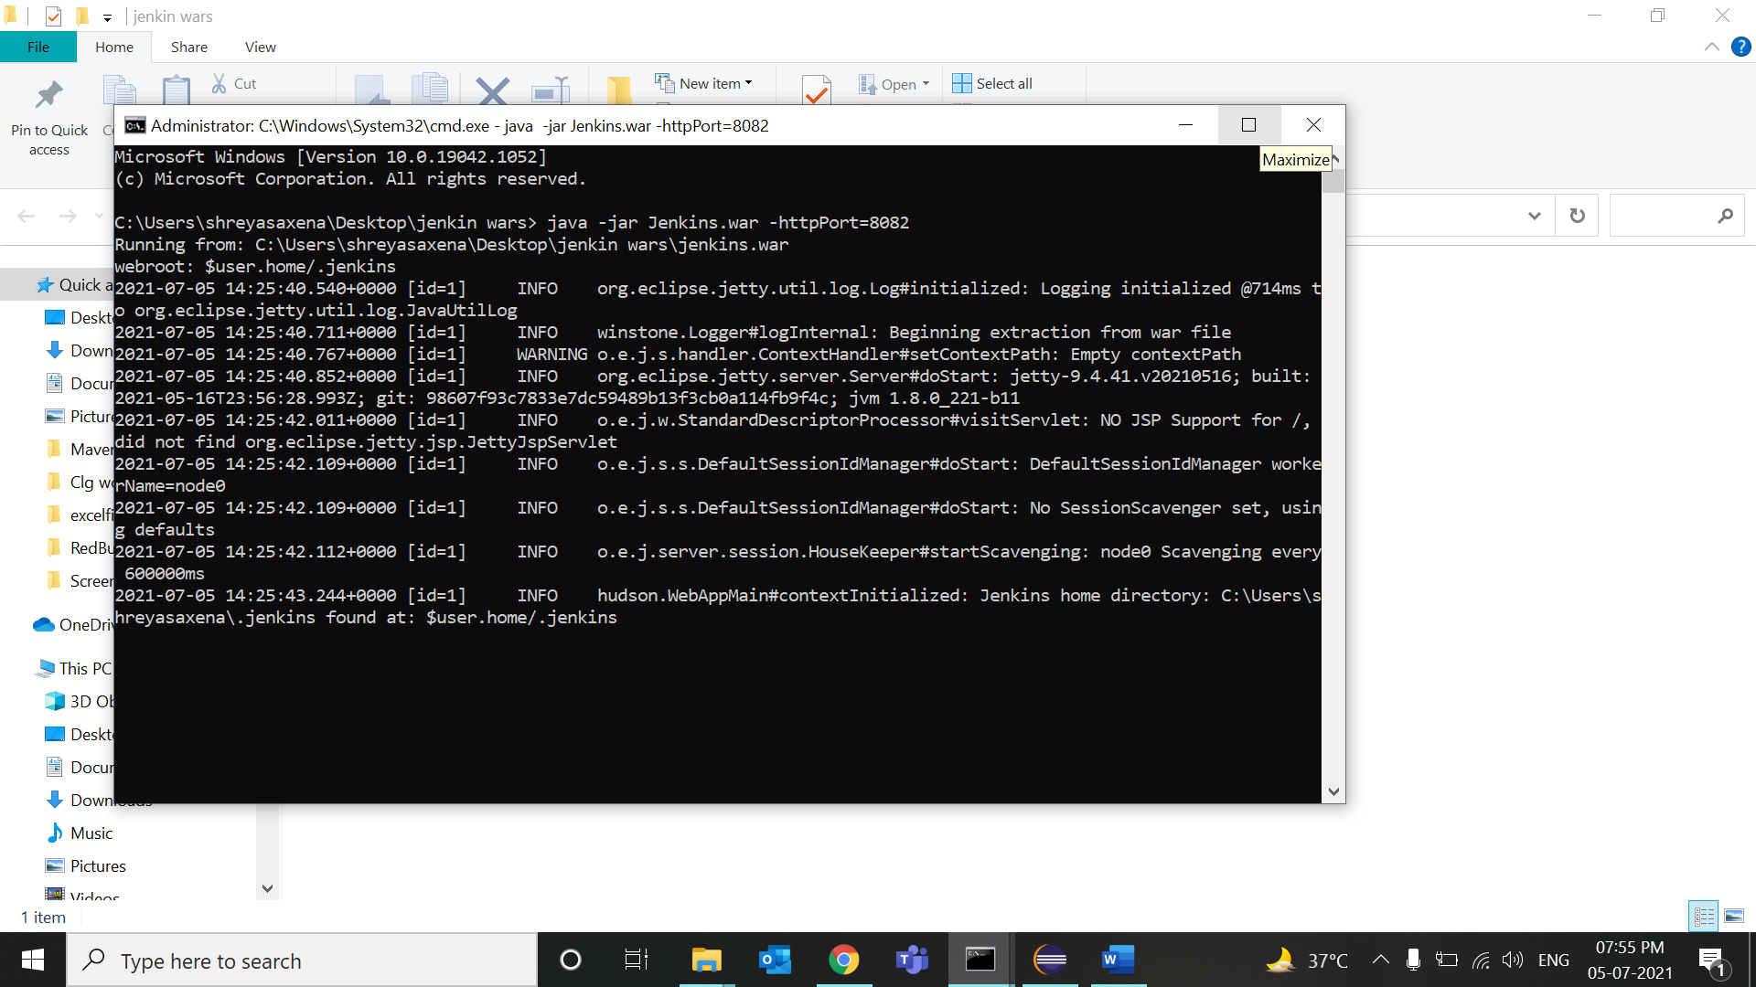

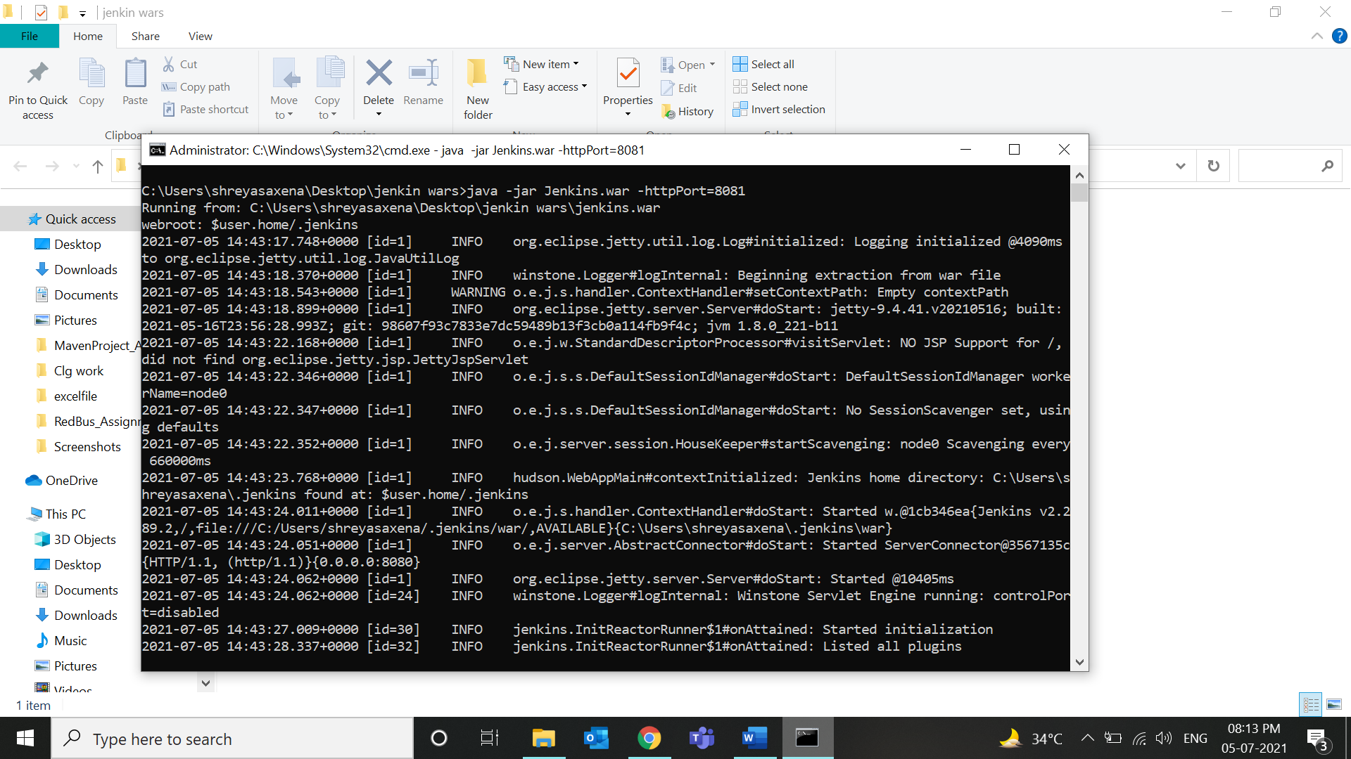

1. Then open Jenkins in your browser and type localhost:8082 (type your port). You will reach to a login page.

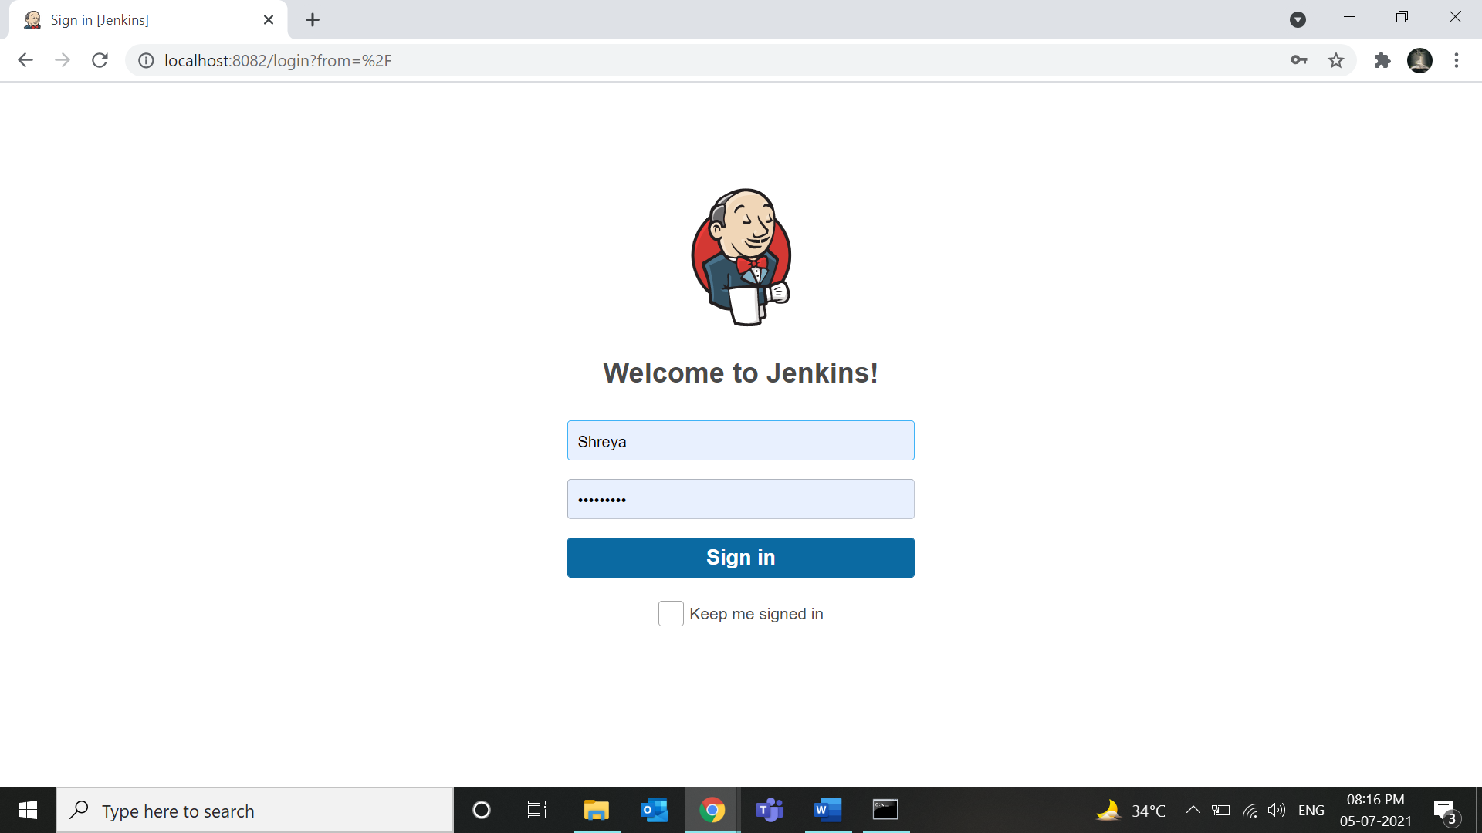

1. Sign into your account (or create your account)
2. Then set global configuration by clicking on manage Jenkins>Global configuration tool
3. And add java and maven paths as shown.

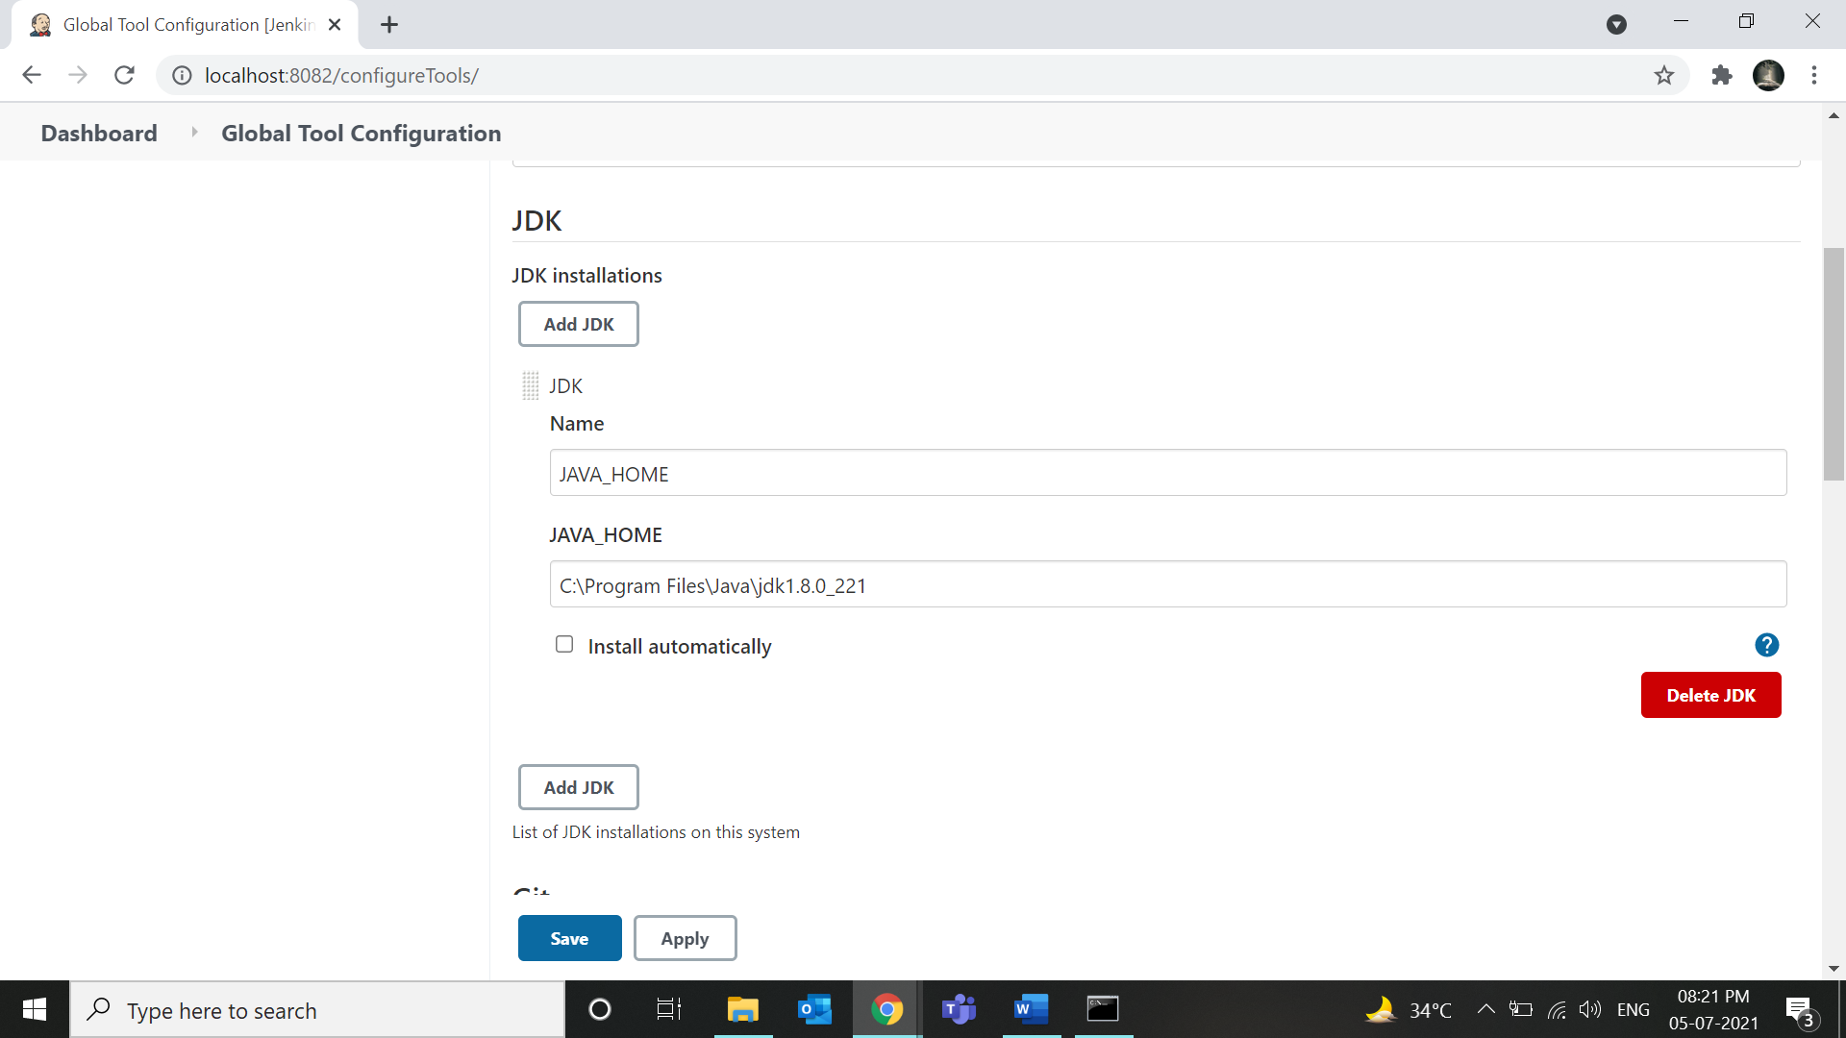

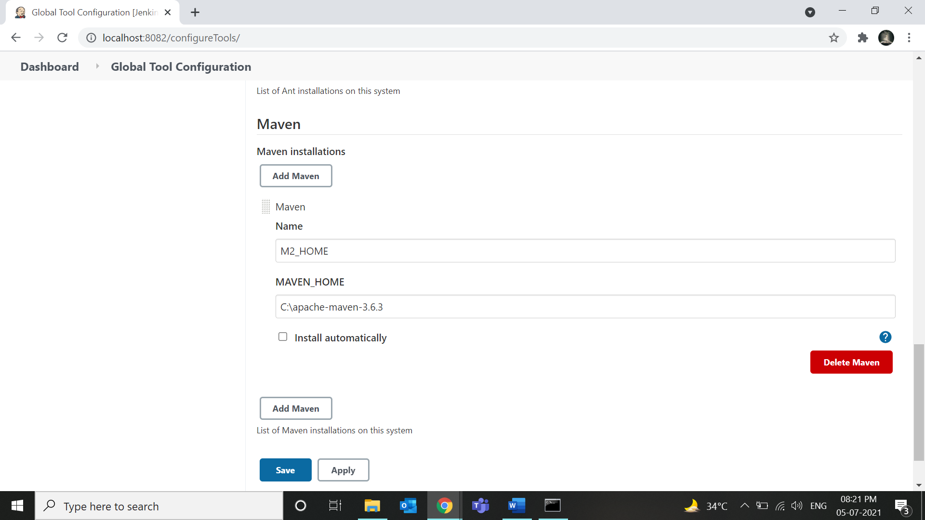

1. Then click on save.

Now you can run Jenkins using Maven project in local or using GitHub

## To run your maven project (from local) on jenkins.

1. Click on Manage Jenkins> Manage Plugins, then Install all the plugins shown below

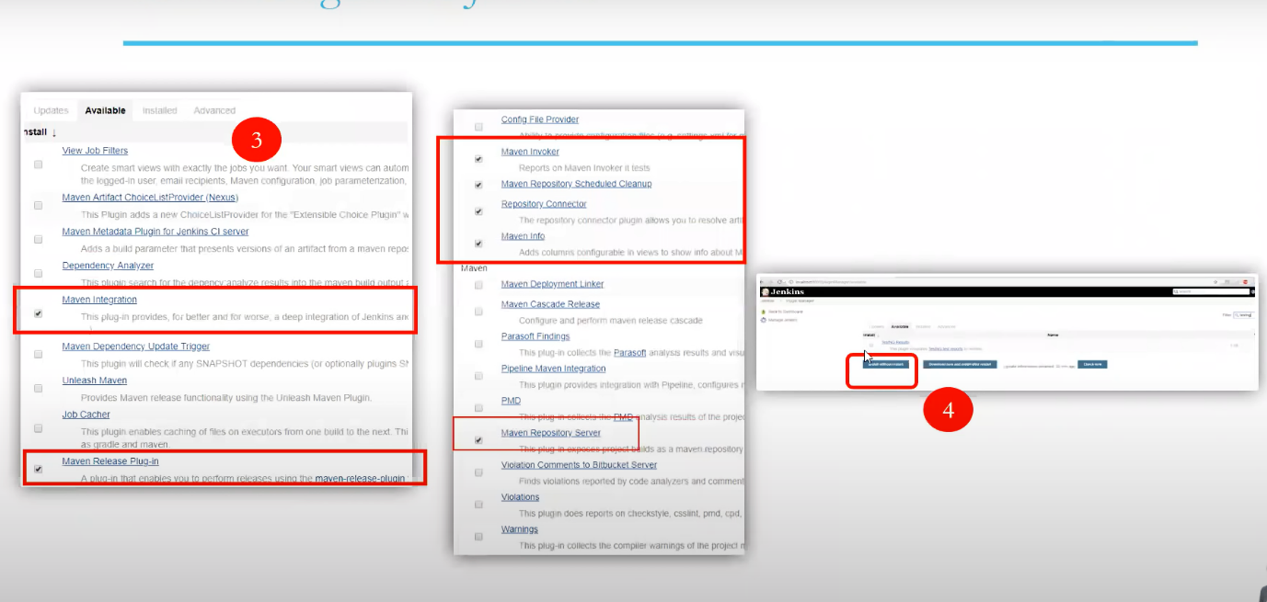

1. After installation click on New Item Then enter a name and click on maven project then click ok.

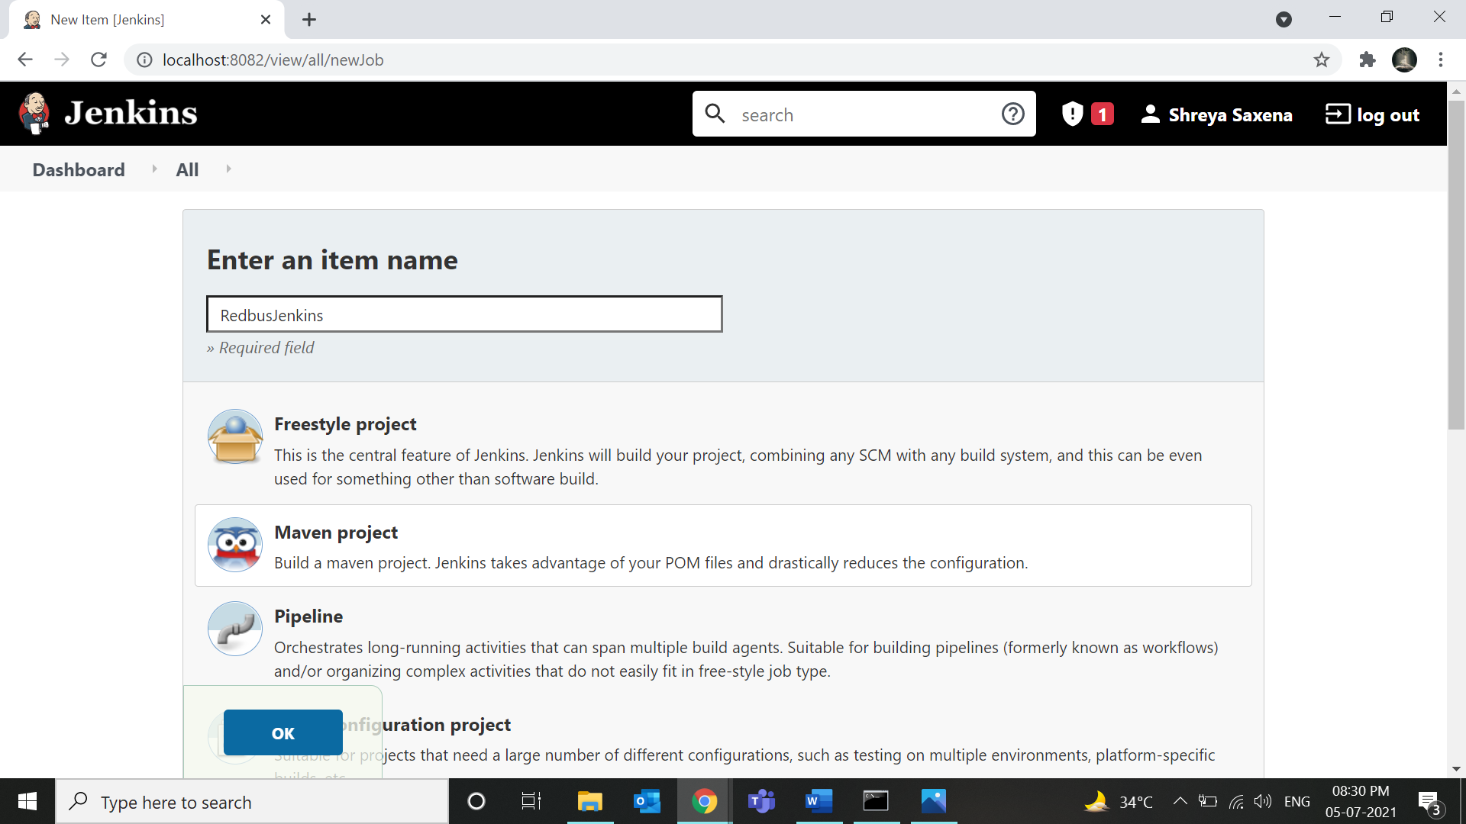

1. Now scroll down to Build and then enter the location of the POM file of your project and write clean install in Goals and options.

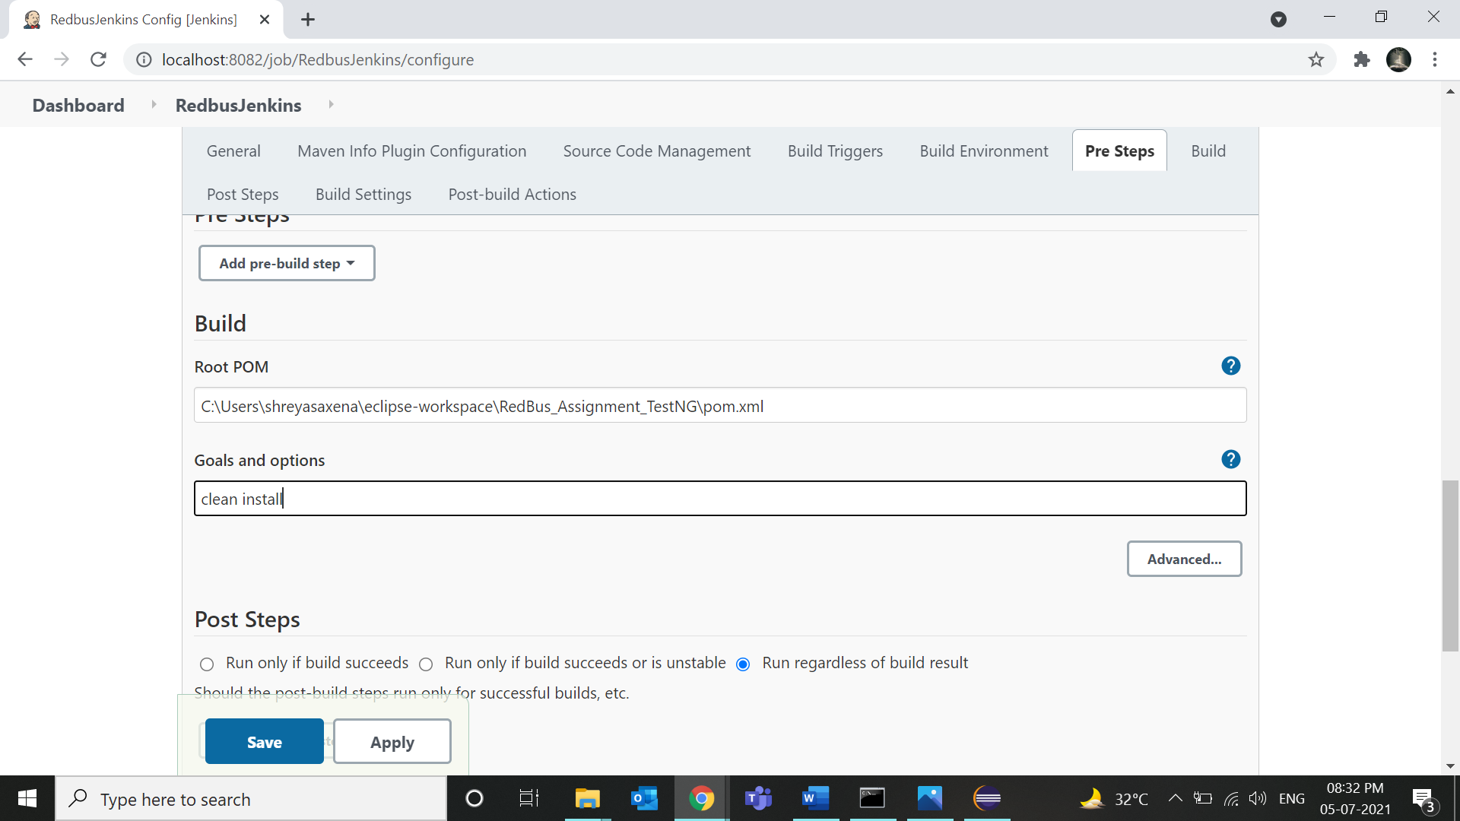

1. After clicking on Save you will reach to project.

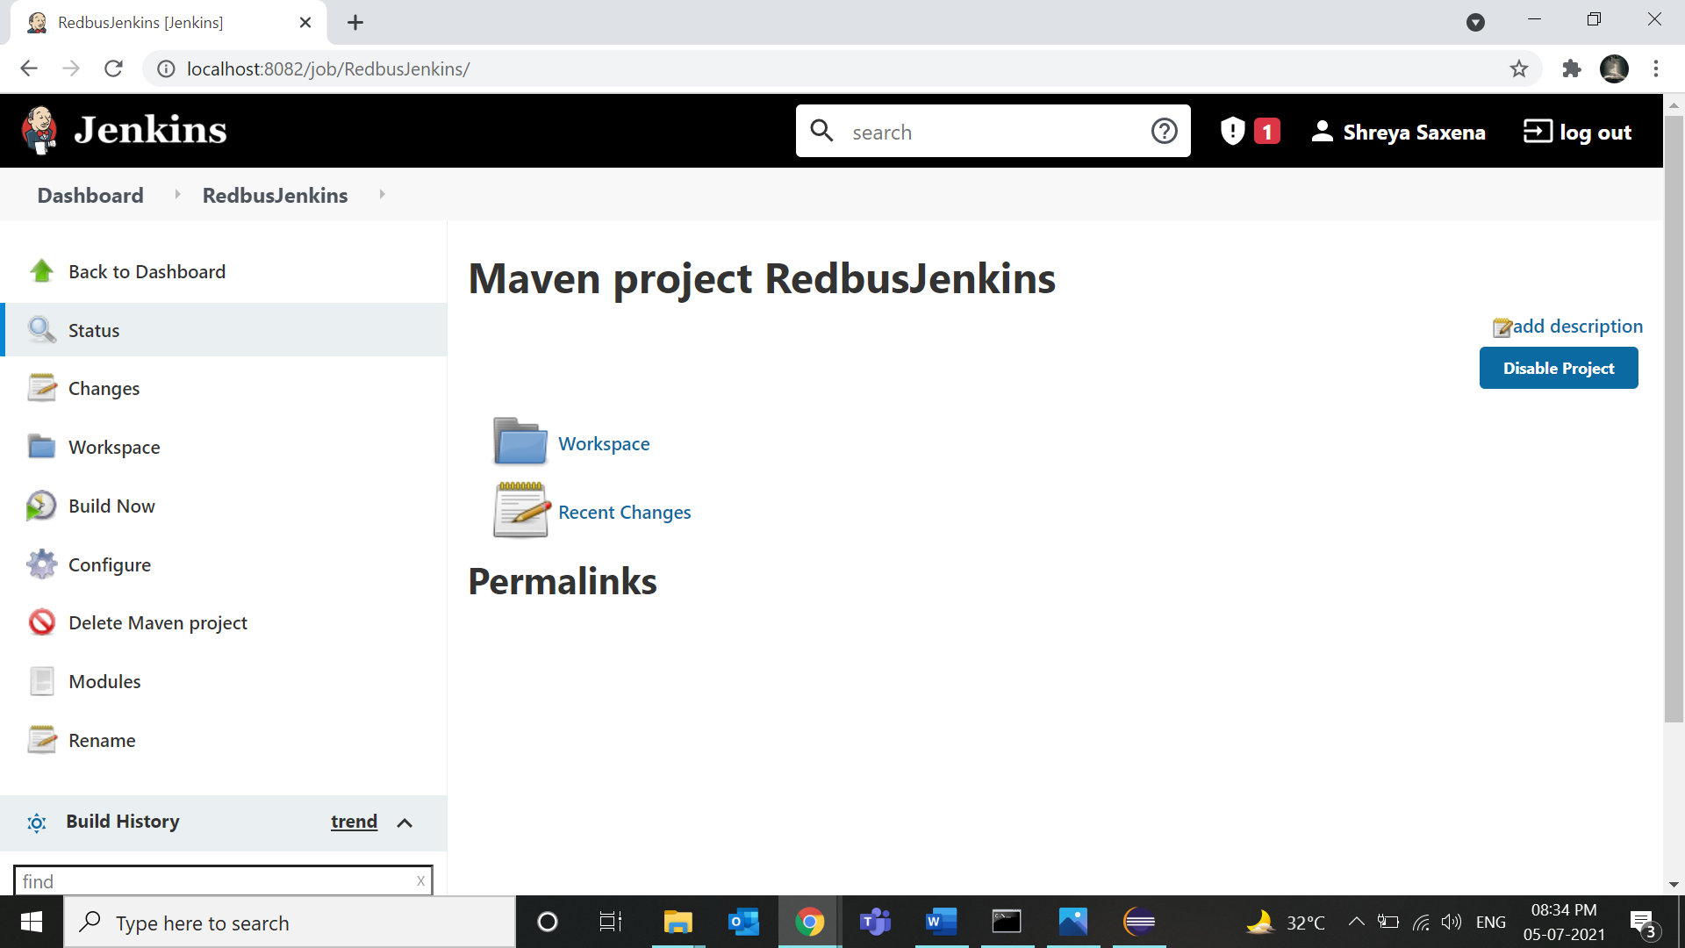

1. Now click on Build Now and then open console output in Jinkins.

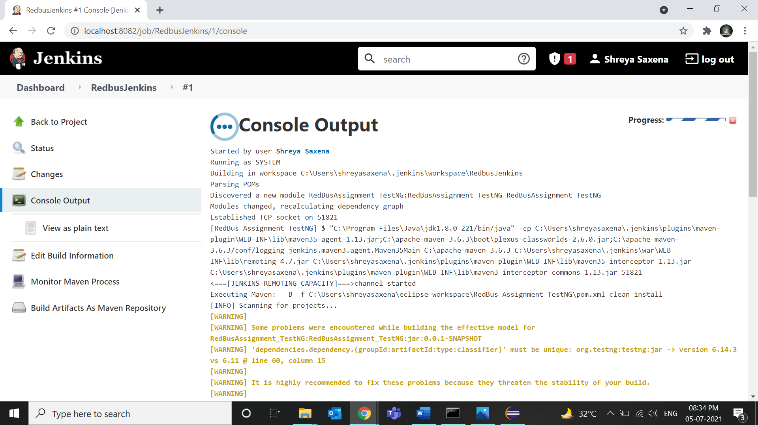

1. Your file starts to run!

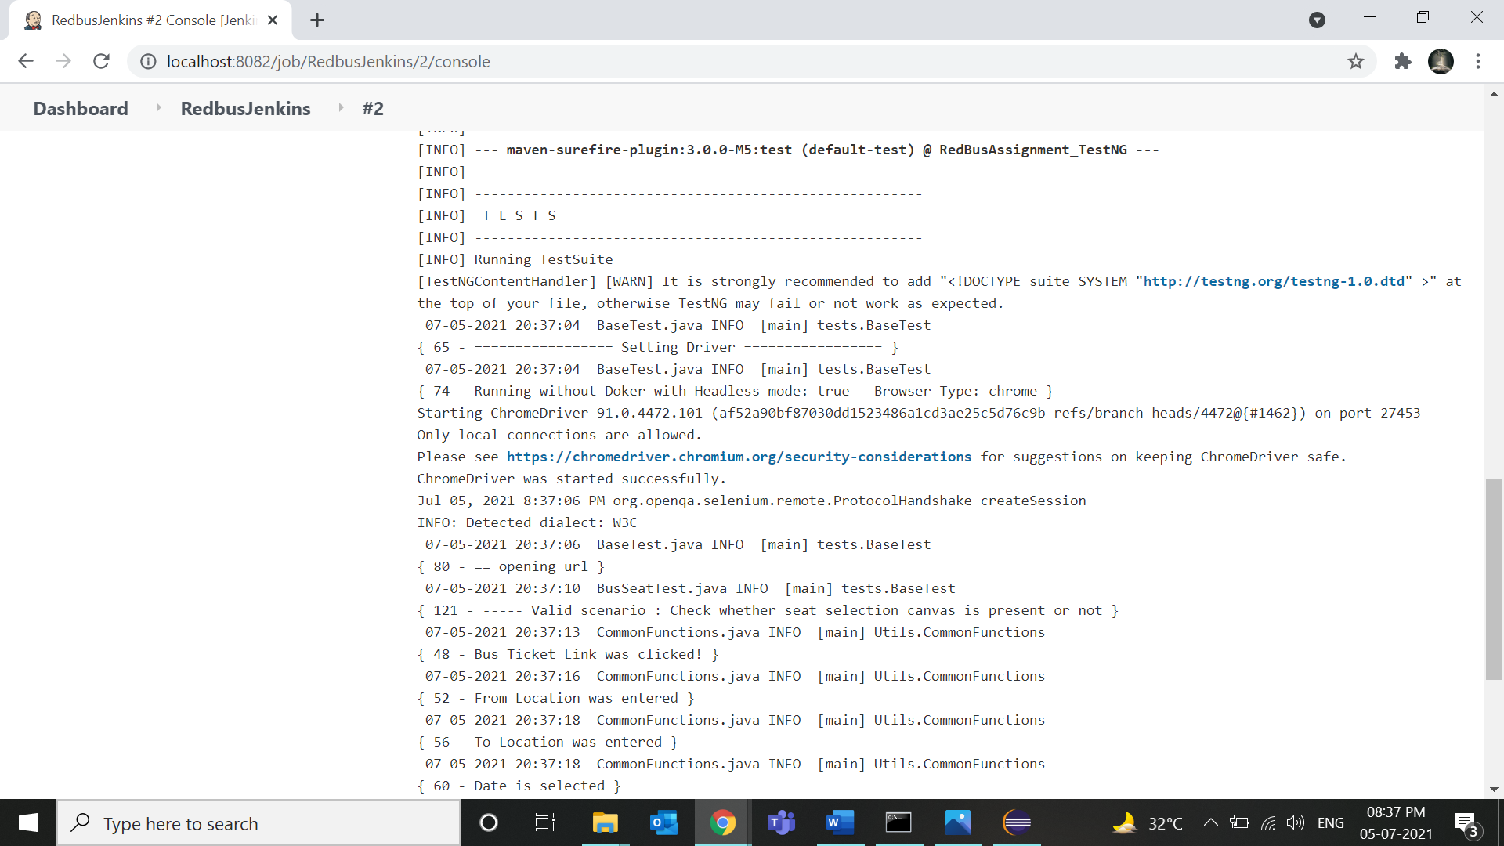

1. Below is the Test result. Run completed on Jenkins!

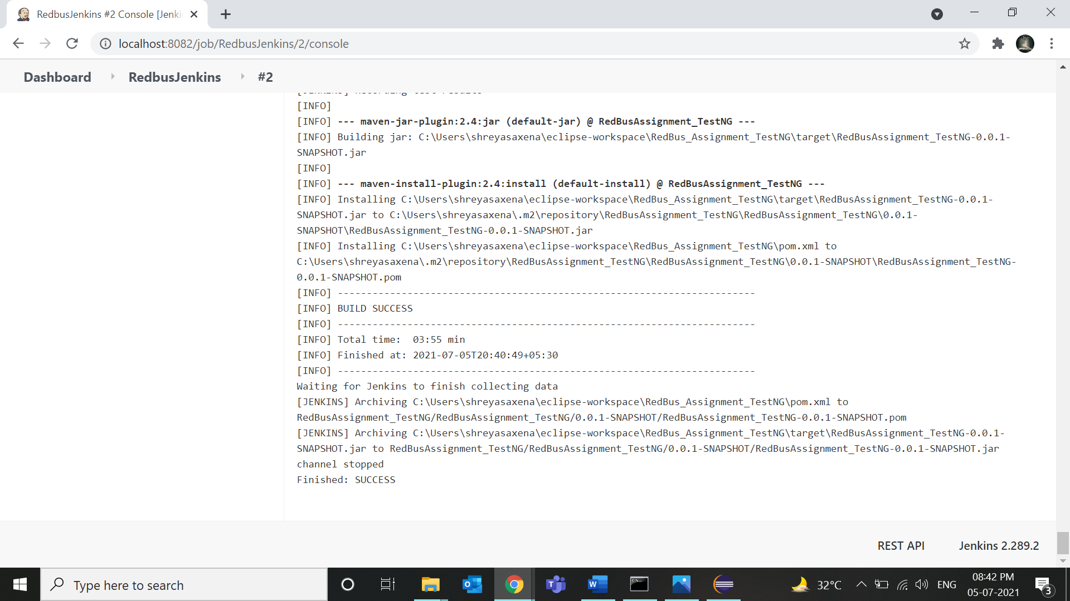

## To run your project (GitHub) on jenkins.

1. New Item Then enter a name and click on maven project then click ok.

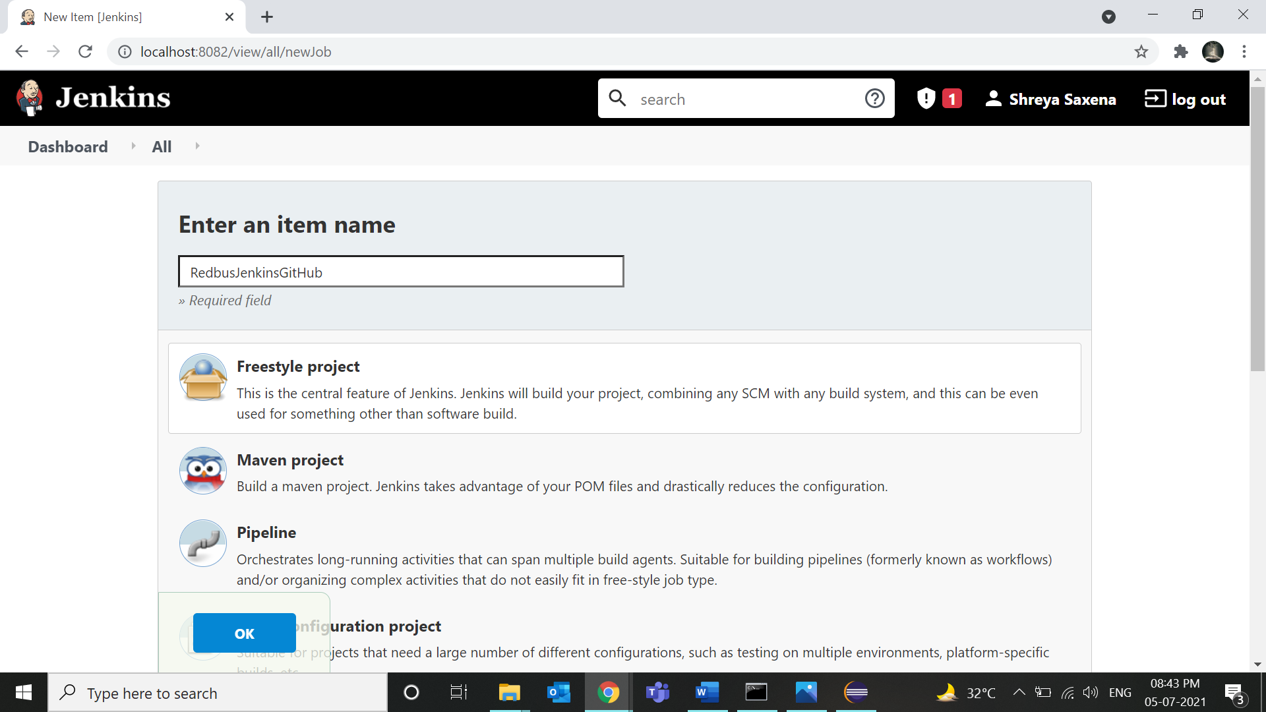

1. Copy paste your GitHub project Repository as shown.

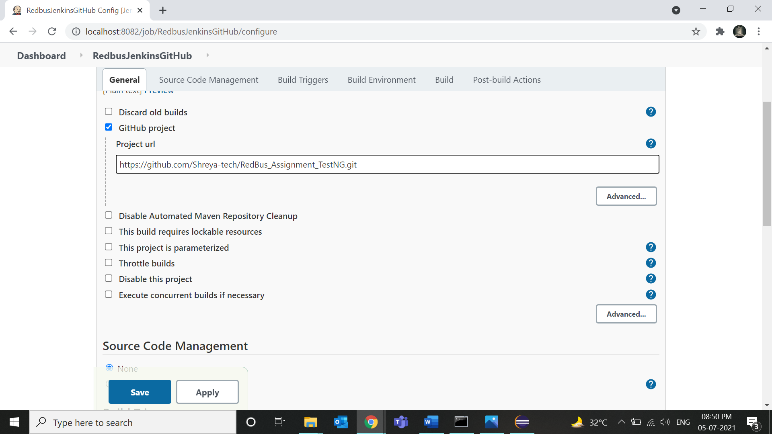

1. Then click on add build steps and choose Windows batch command.

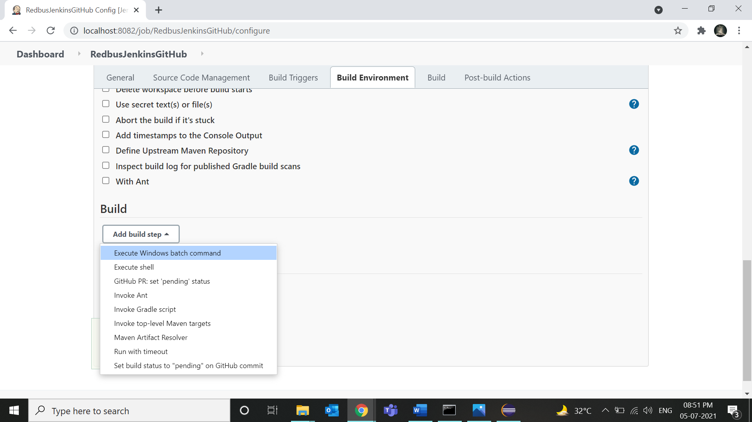

1. Type mvn clean install as shown. And save.

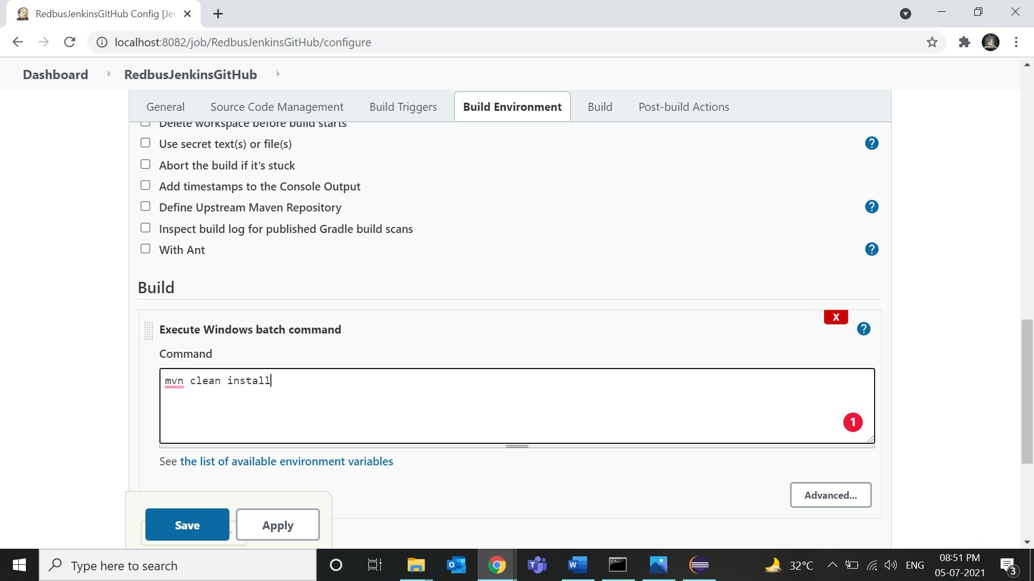

1. Then you will be directed to project.

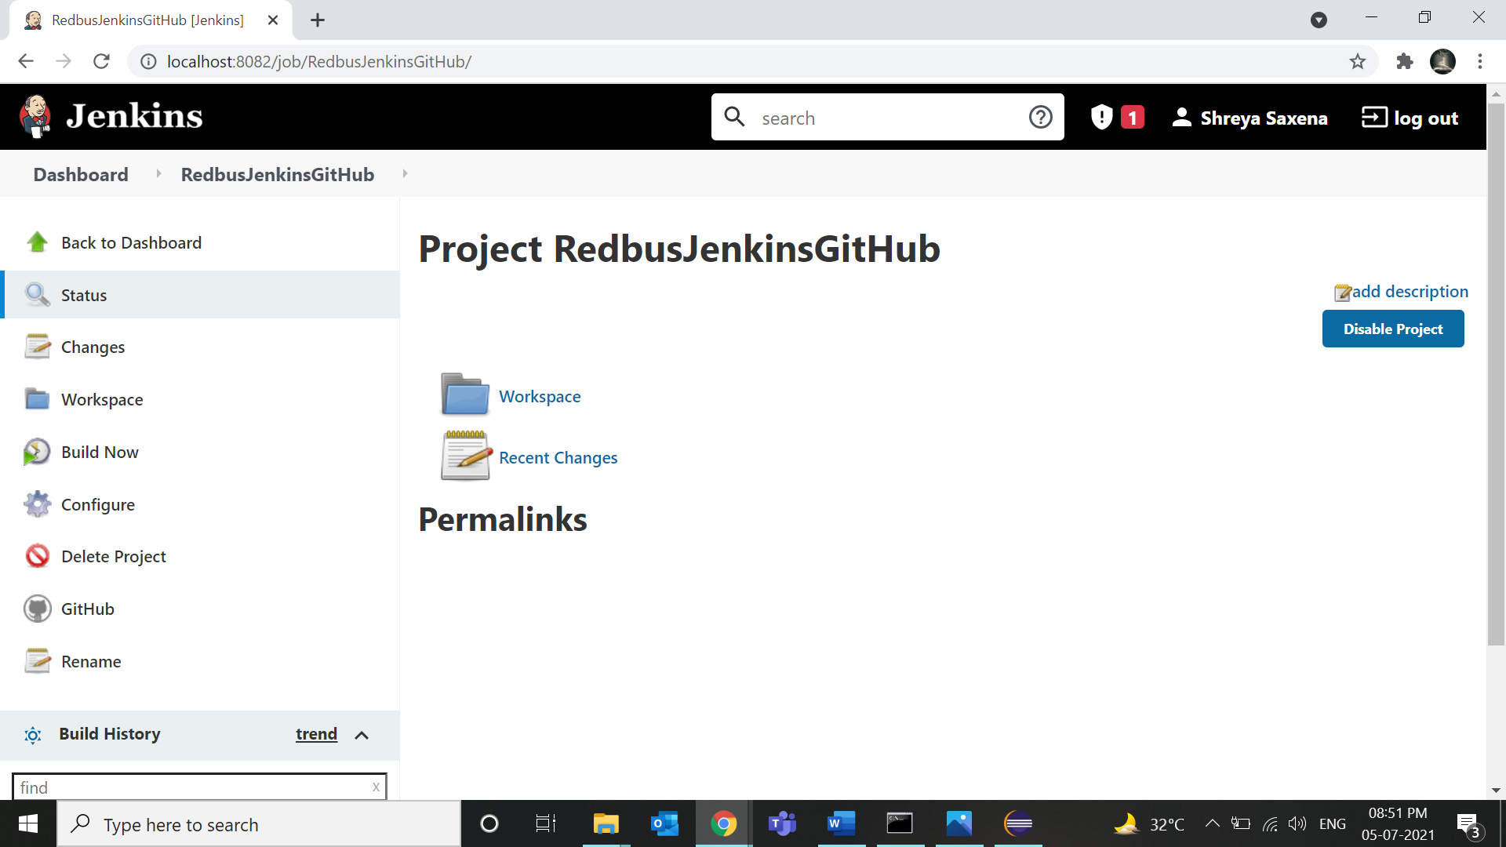

1. Then click on Build now and then open console output in Jinkins.

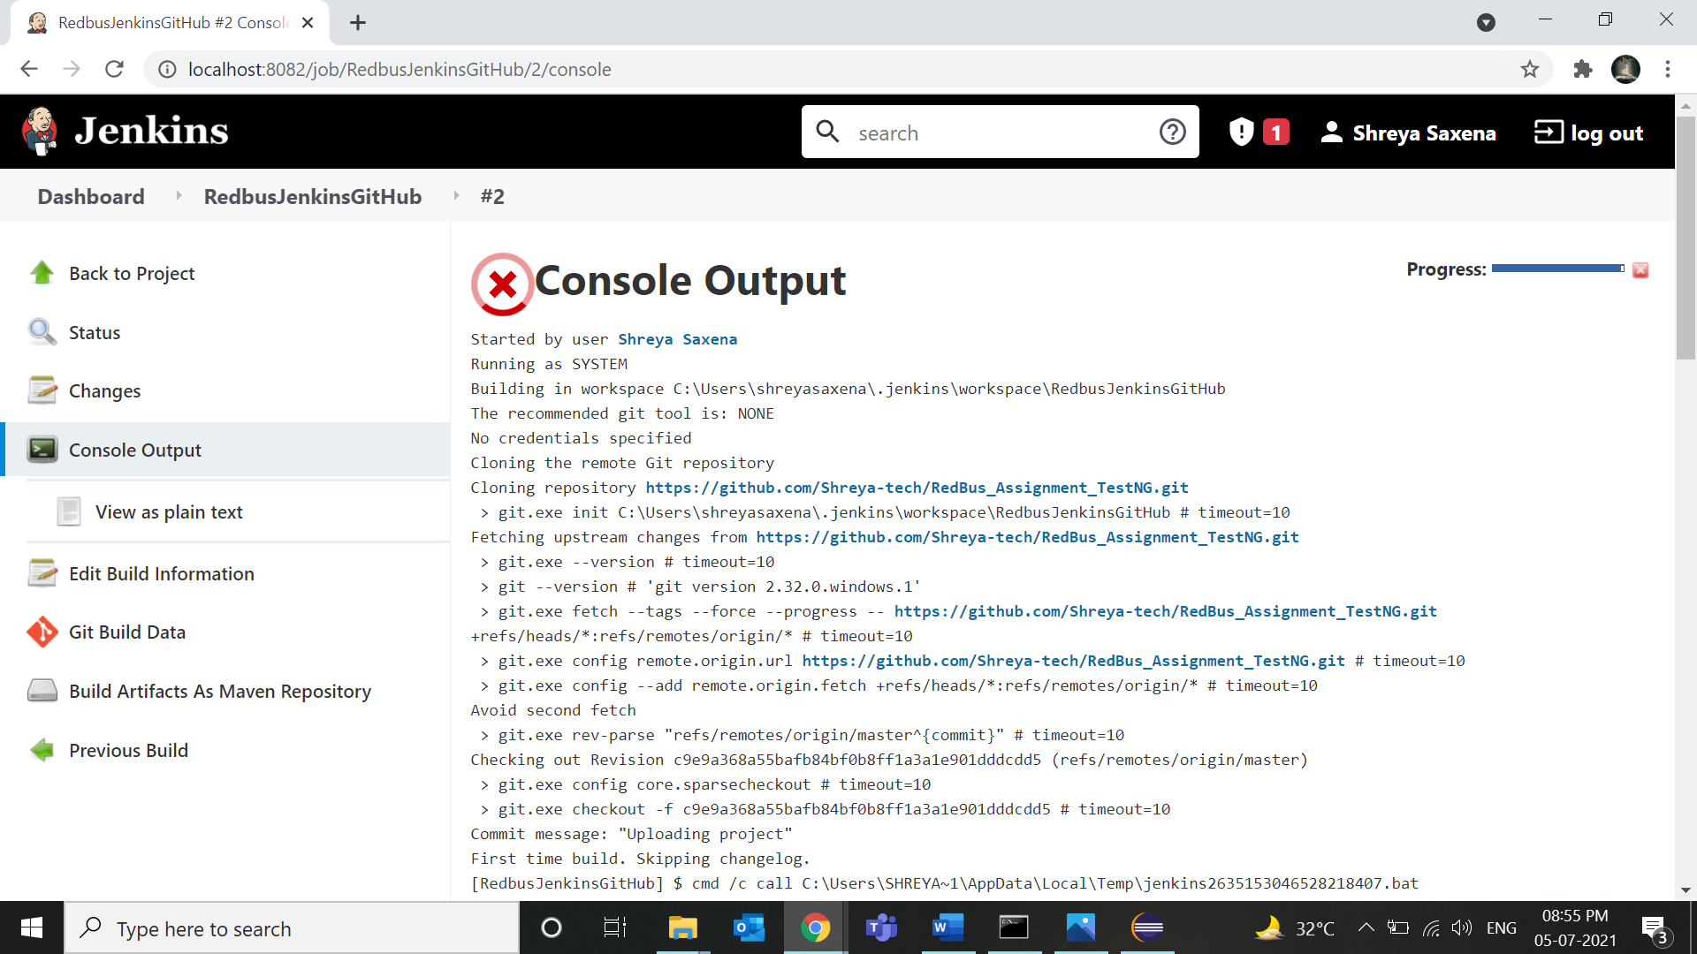

1. Your file starts to run!

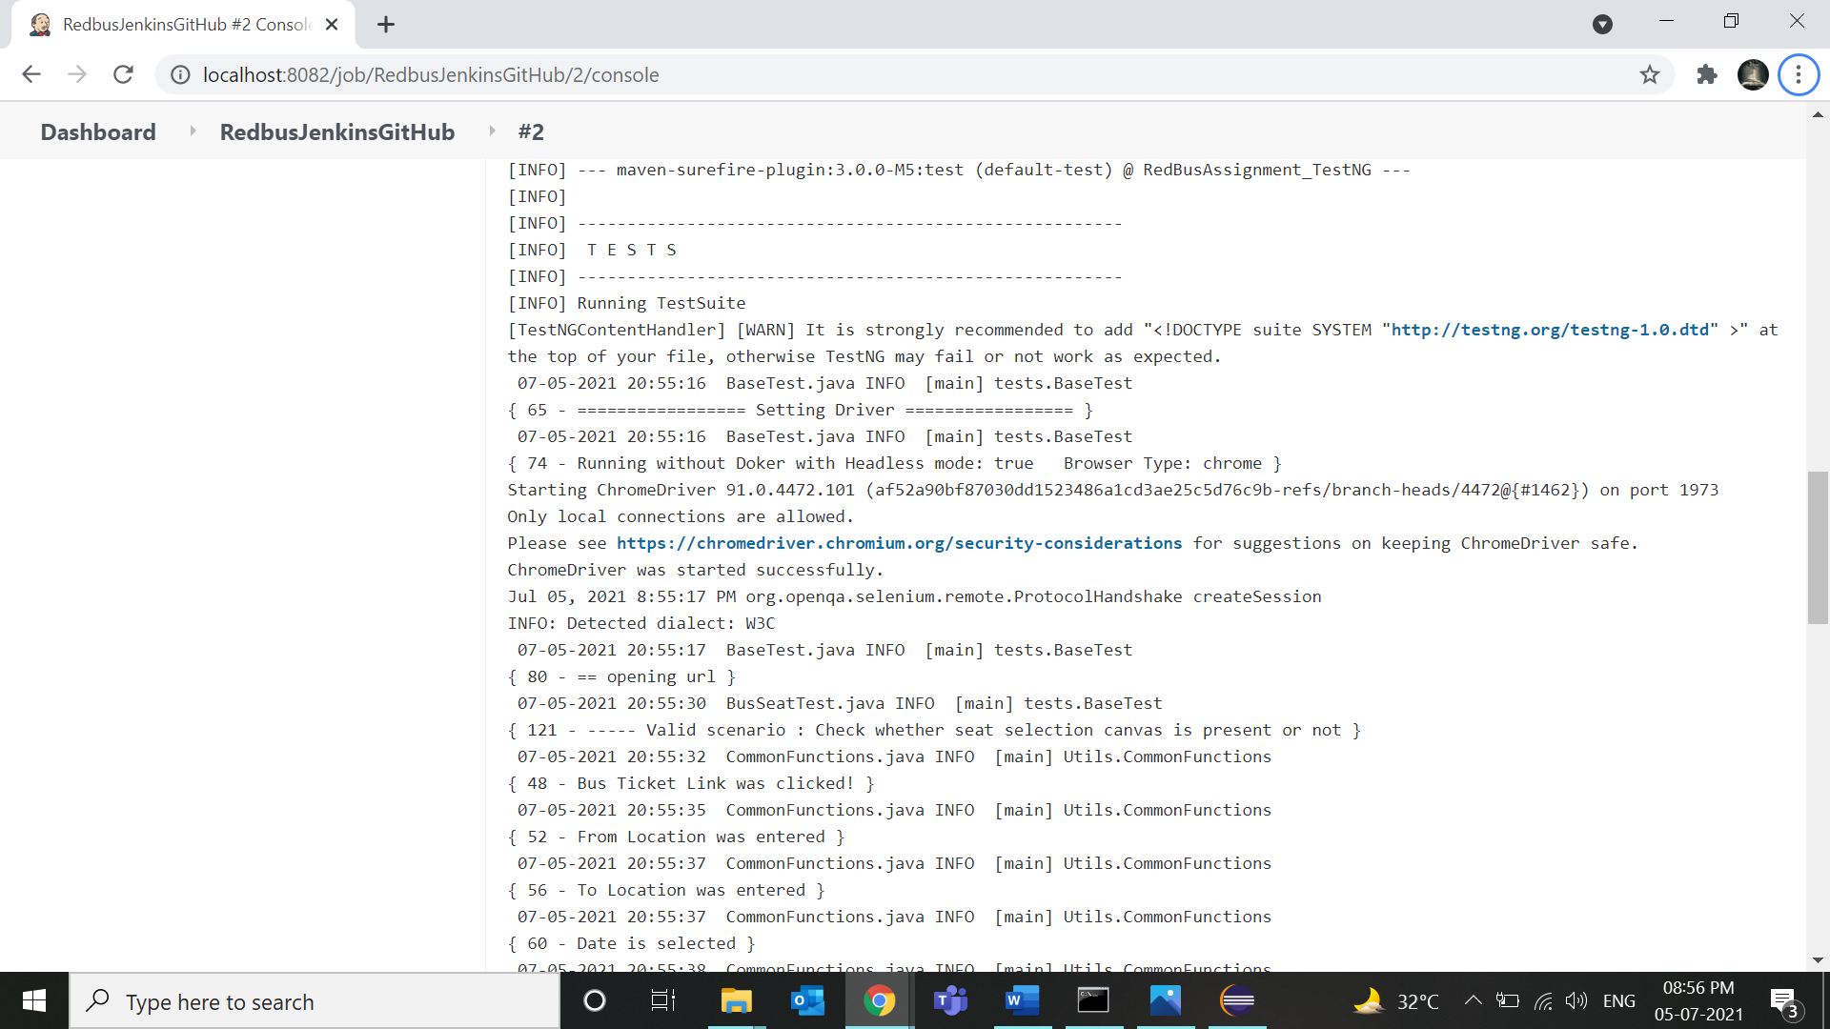

1. Output.



    